# Historical Scots

## Week/Lecture 1: Intro + History

Robert Burns (1759-1796) – most popular association with Scots

* *To a Mouse*

Hugh MacDiarmid (1892-1978) (the main figure of the Scottish Renaissance in the early 20th century): “Not Burns: Dunbar!”

* William Dunbar
  + Scottish *makar* (1459/60 – c.1530)
  + A wide range of genres:
    - celebratory
    - political
    - religious and moral
    - satirical/courtly entertainment
    - personal

Literature in Scots (1375 onwards)

* *The Brus* (1375) by John Barbour
  + A 14 000-line poem about the Scottish Wars of Independence (1274-1329)

Evidence of the earliest Germanic language of the North: **Old Northumbrian**

* The Ruthwell Cross in Dumfriesshire (early 8th c.)
* Old Northumbrian is an ancestor to Scots

Who came when to Scotland?

* Normans, Vikings, Romans, Anglo-Saxons, Celts, northern English migrants
* Chronological order:
  + Romans
  + Scoti (Celts)
  + Anglo-Saxons
  + Vikings
  + Normans
  + Northern English migrants

Above the Solway Firth-Tyne line

* Gaelic = the language of the Scoti (the Celtic-speaking Scottish kingdom)
* northern Germanic dialects (Anglian / Old Northumbrian)

Lexicographic resources

* DSL – Dictionary of the Scots Language
  + Dictionary of the Older Scottish Tongue (up to 1700)
  + Scottish National Dictionary (1700-1945)
* John Jamieson’s (1808) *Etymological Dictionary of the Scottish Language* (first historical dictionary of Scots)
* OED – Oxford English Dictionary

## Lecture 2: Scots – Its Own Language

Intelligibility criterion:

* English vs Dutch vs Spanish (no understanding)
* Cockney vs Geordie vs Scouse (general understanding)
* Counter examples:
  + Dutch vs Flemish
  + Danish vs Norwegian
  + Czech vs Slovak
  + English vs Scots ?

National criteria

“Definitions” – “A language…”:

* “is a dialect with an army and a navy”
* is a variety which has a cultural, ethnic and historical significance
  + different enough from surrounding – potentially intelligible – varieties
* is a useful shortcut label:
  + Old English, Middle English, Early Modern English

Crop/clip of family tree:

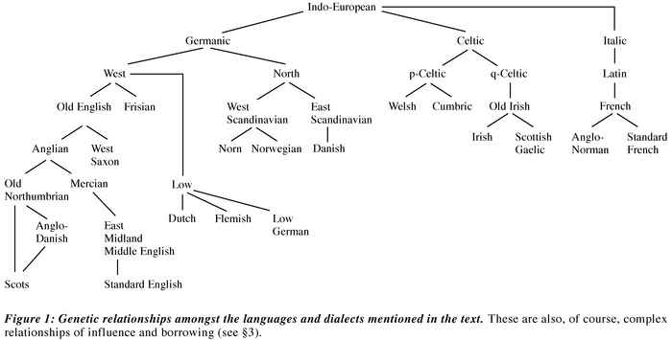

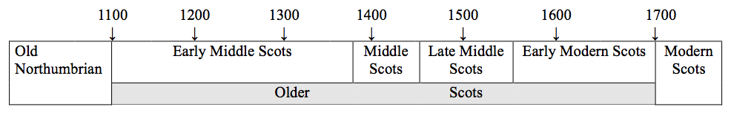

A revised timeline of the history of Scots,

based on linguistic and extralinguistic criteria (Kopaczyk 2013)

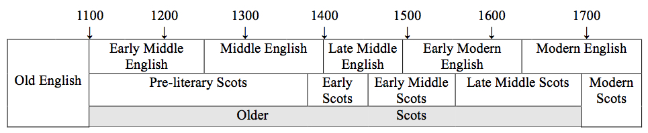

Linguistics differences between Middle Scots (dialects) and Middle English (dialects):

* A linguistic variable
  + the same feature which can have multiple realisations in different varieties (languages/dialects)
  + Orthographic ex: <sch> in the north ~ <sh> in the south
  + Phonological ex: /u/ in the north ~ /au/ in the south
  + Grammatical ex: *speik****and*** in the north ~ *speik****ing*** in the south
  + Lexical ex: *burn* in the north ~ *stream* in the south

Text example: Richard Holland’s “The Buke of the Howlat” (1440s, printed in 1507)

* Diagnostic variants: Spelling (with same sounds)

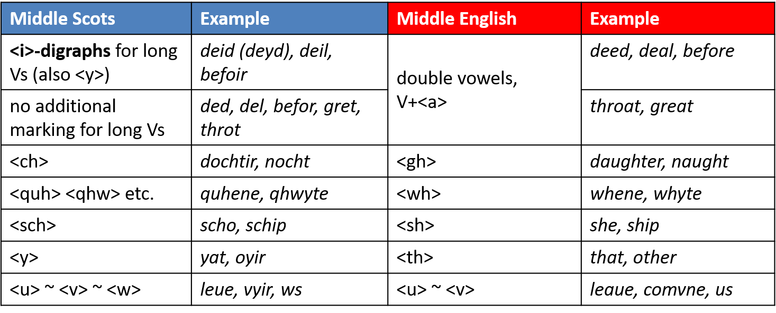

* Diagnostic variants: Spelling (with different sounds)

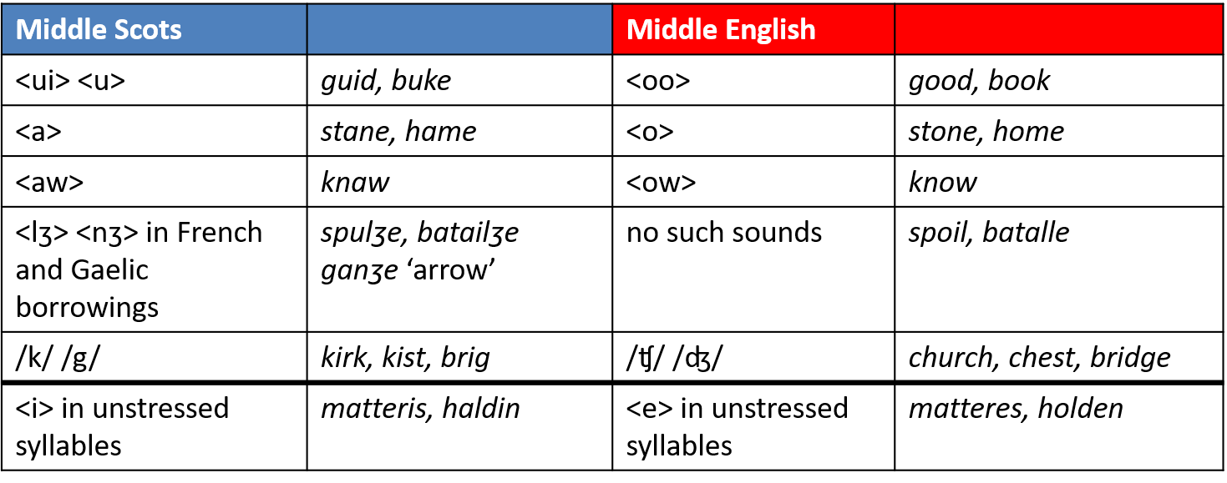

* Diagnostic variants: Grammar

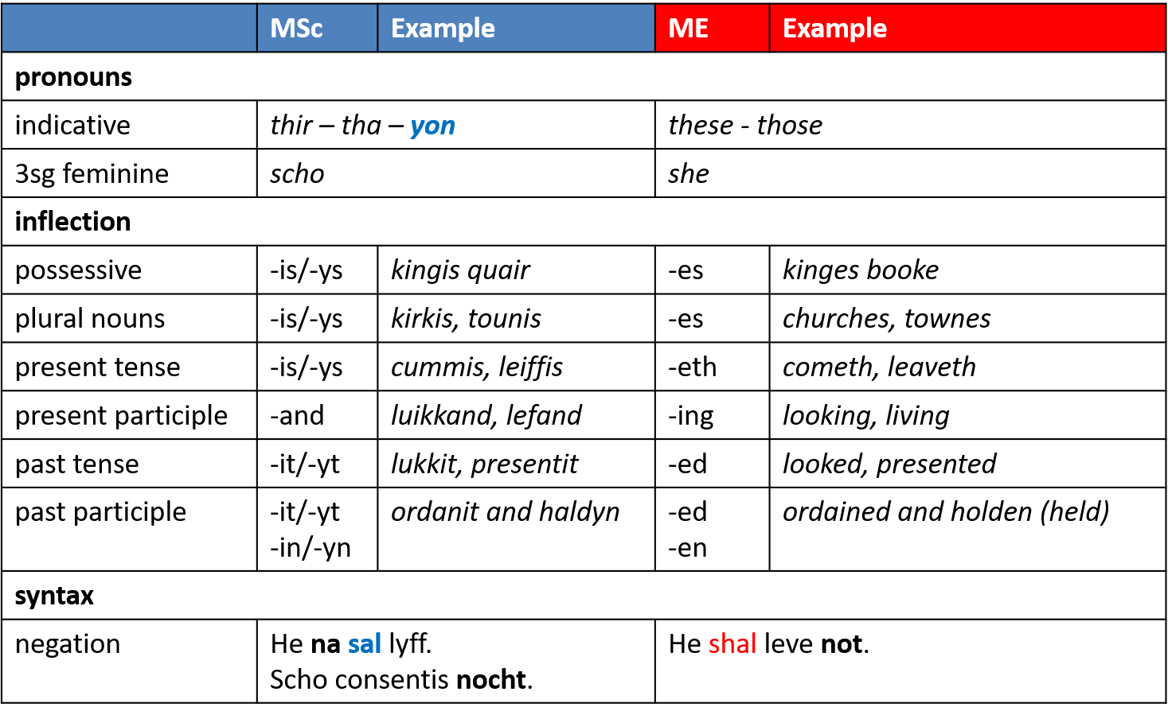

* Diagnostic variants: Lexis

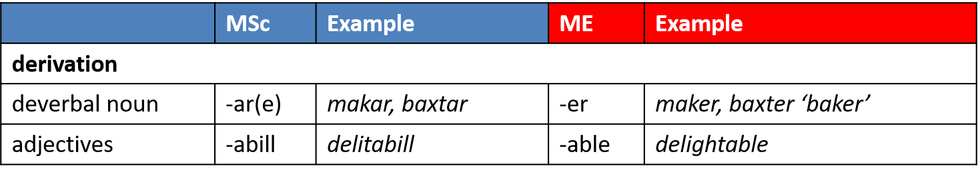  
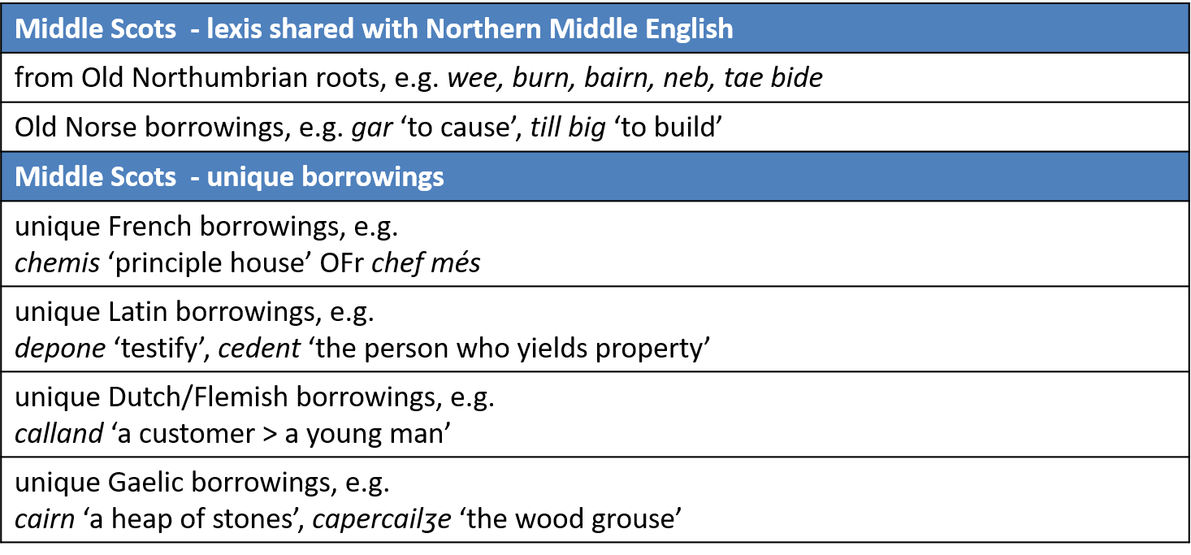

## Lecture 3: Language of Educated People

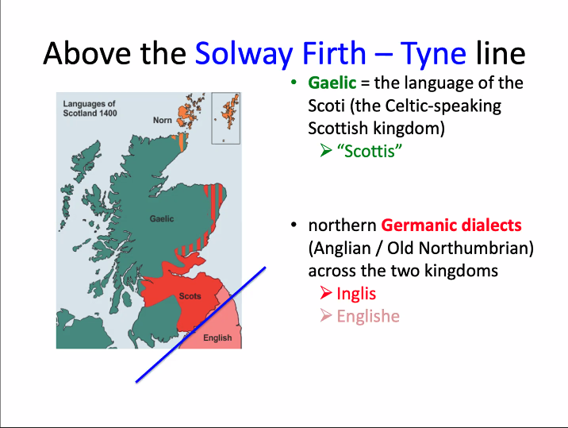

‘Inglis’ as referring to Scots

* Androw of Wyntoun (c. 1420)

‘Scottis’ as referring to Scots

* Gavin Douglas (1513), *The Aeneid*
  + First translation of Virgil’s *Eneados* into any Germanic language
* ‘Scottis’ = ‘Sudroun’ in the South

NB:

* The texts surviving in manuscripts and early print pre-1700 reflect language use of the best educated and most influential sectors of society

Scots as the language of aristocracy and courtly entertainment

* *The Flyting of Dunbar and Kennedy*
  + William Dunbar (1460?-1513?/1530?)
  + Walter Kennedy (1455?-1518?)
  + c.1490-1501
  + May have been performed at the court of James IV (1488-1513)
  + Survives in Chepman and Myllar prints from 1508 – one of the earliest printed texts in Scotland
  + ‘an exercise in *vituperatio* … **a full-scale competitive exchange of insults**’ (Burrow 2006: 142)
* *The Flyting of Montgomerie and Polwart* 
  + c.1585
  + Court of James VI (1567-1625)
* *Ane Schort Treatise Conteining some Revlis and Cautelis to be obseruit and eschewit in Scottis Poesie* (1584)
  + James VI
  + English and Scots poetry is different, although the languages are similar
  + Printers changed ‘yogh’ to ‘z’
  + Talks about choice of words in poetry based on topic
  + About alliteration
  + About poetic form
    - Sonnets: 14 lines, 10 feet in every line
  + About flyting:
    - Short words, hurled across a ‘heuch’ (precipice, cliff, hill)

Flyting

* ‘Allusions […] suggest that verse flyting was carried on in public, on winter nights, in the presence of one’s opponent and the king’ (Bawcutt 1992: 233)
* Places: Holyrood Palace, Stirling Castle’s The Great Hall

Elizabeth I

* “She possessed nine languages […]
* Including Scots

Recap:

* Before 17th c., upper classes did not have English – their language was Scots
* The surviving textual material was written by the best educated people (clerks, scribes, poets) and gives us more info about the language of the social strata
* Glimpses of ‘street talk’ in courtly entertainment

## Lecture 4: Variety of Functions

Four-stage model: To become a fully-fledged standard language:

* selection
* acceptance (diffusion and maintenance)
* ***maximal* variation in function**
  + Elaboration (new registers, topics, text types)
* *minimal* variation in **form**
* (Haugen (1967), cf. Milroy and Milroy (1991)

Literary texts

* low style (last lecture) vs high style
* Lofty themes need:
  + Complex word order
  + Latin(ate) vocab
  + Rhetorical devices
* William Dunbar’s *The ballade of … Barnard Stewart …* (May 1508)
  + Latinate vocab
    - Latin
    - French
    - Latin mediated through French
    - Impact:
      * Connotations, rhyme
      * Fancy acrostic
* W. Dunbar’s *Lament for the Makaris* (c.1505)
  + Scots spellings indicative of pronunciation and grammar
  + Latin for chorus (and ‘and’)
  + Multilingual repertoires

Elaboration of function

* Ausbau
  + Developmental stages on the way to the status of a ‘standard language’ > in written non-literary language
  + Folk to Elevated to Research
  + Local to Humanities to Science

James Douglas to Henry IV (1405)

* Northern Subject Rule (Northern Present Tense Rule)
  + OSc (Older Scots) present tense concord is NOUN + *has, -is (-ys)*
  + unless the subject is
    - singular pronoun (*I*) or a plural pronoun (we, ye, thai)
    - AND
    - the pronoun is next to the verb
  + then no inflection

Legal language

* Acts of Parliament
  + Legislation of James IV (1496)
  + THE NEVV ACTIS (1540)
  + Scots: The language of the king, parliament, state
* Administrative records
  + Snippets from burgh records of Glasgow and Edinburgh in 16-17th centuries
    - Edinburgh, 1 October 1588
    - Contribution Spayngyearts
* Trial proceedings: witchcraft trials
  + The deposition of Bessie Dunlop (1576)
    - National Records of Scotland,
    - Language of record – Scots
    - Language of testimony – Scots (reported speech, narratives)

Religion:

* Murdoch Nisbet, *The Bible* (c. 1520)
  + Diagnostic variants: <y> for th, <sch> for sh, <quh> for /xw/, yogh for /j/
  + Spellings indicating Scots pronunciation
  + Negation after verb

Science and History:

* Gilbert Skeyne’s *Ane descriptioun of the pest…* (1568)
  + First **medical** book in Scots
  + Pest – plage in Edinburgh in 1568
* Robert Lindsay of Pitscottie, *The* ***Historie*** *and Cronikles of Scotland* (before 1577-1579)
  + Southern spelling conventions within Scots

Abroad:

* Patrick Orem’s will (1609)
  + Krakow, Poland

Apart from multiple literary genres, Scots is used in:

* legal discourse
* administrative texts
* religious treatises
* scholarly prose
* official letters
* private letters

Next week: codification (linked to prestige)

## Lecture 5: Older Scots – What Happened?

Standardisation of Scots:

* (initial) selection: ~1440 - ~1520 (Kopaczyk, 2013)
* *Basilikon Doron* by James VI

Anglicisation:

* Writer chooses
  + English spelling conventions (different enough from Scots, but both orthographic systems are still in flux at that time)
  + English grammatical patterns and inflections
  + English vocabulary (but there’s shared vocabulary from Old French and Latin)
* Reasons:
  + English was NOT written down (or spoken) in medieval and early modern Scotland daily, but
    - there was familiarity with English writing, especially after the introduction of print, e.g., Protestant English printer fled to Scotland during Mary Tudor’s reign (1553-1558)
    - other Protestant dissenters fled to the Continent: the Geneva Bible (1560) printed in English and disseminated in Scotland (1579 – every household should have a copy)
    - writers could choose to introduce English features on purpose to make a political/religious/cultural point (cf. John Knox)
  + like today, Scots and English were intelligible to a large extend
    - unlike today, Scots and English were both unstandardised and on the path towards linguistic standardisation
    - Anglicisation could have been a conscious effort (‘change from above’) by a particular writer, but didn’t have to be (‘change from below’)

When researching language through text, bear in mind:

* Corpus of texts
  + Size, representativeness, editorial issues, etc
* Methodology
  + Variables, categories, counting methods, etc

Language standardisation – minimal variation in form by **codification** (grammars, dictionaries)

* **This stage wasn’t reached by Scots at a crucial point in the past**
  + “The Age of Learning and Politeness” – 18th century
    - social mobility <-> recognising social hierarchies as part of state stability
    - Establishing your place – through appearance, possessions, manners, **language**
    - After 1700:
      * English in the south had already produces a standard that was (and still is) perceived as a model of linguistic correctness
      * Scottish writers adopted this model as a default in many genres
        + Scots was still used, so literary authors could employ it for specific purposes

New attitudes:

* Rejecting Scots
  + Thomas Sheridan and his elocution lessons in Edingurgh in 1761
    - The Select Society for Promoting the Reading and Speaking of the English Language in Scotland
    - ‘…even persons well advanced in life may be taught, by skilful instructors, to avoid many gross improprieties, in quantity, accent, the manner of sounding the vowels, &c. which, at present, render the Scotch dialect so offensive.”
  + Essays:
    - 1764: James Buchanan’s *An Essay Towards Establishing a Standard for an Elegant and Uniform Pronunciation of the English Language, throughout the British Dominions as practiced by the Most Learned and Polite Speakers*
    - 1776: William Perry’s *The Only Sure Guide to the English Tongue*
      * “to fix a standard for the pronunciation of the English language, conformable to the present practice of polite speakers in the city of London”
    - 1791: John Walker’s *A Critical Pronouncing Dictionary* with “Rules to be Observed by the Natives of Scotland for attaining a Just Pronunciation of English”
      * over 100 reprints up to 1904
  + David Hume
    - Philosopher (empiricist, naturalist, sceptic)
    - 1711-1776
    - “Notwithstanding all the Pains, which I have taken in the study of the English Language, I am still jealous of my Pen. As to my Tongue, you have seen that I regard it as totally desperate and irreclaimable”
      * in a letter to John Wilkes, 16 Oct 1754
* Maintaining Scots
  + Poetry Collections
    - Watson’s Choice Collection of Comic and Serious Scots Poems (1706, 1709, 1711)
    - Thomas Ruddiman republishes Douglas’ *Eneados* (1710) with a glossary
    - Allan Ramsay’s *The Teatable Miscellany or a Collection of Choice Songs*
      * 1724-1727
    - Robert Burns (1786)
  + John Jamieson’s Preface to *Dictionary* (1808, 1st ed.) (of the Scottish Language)
* Leaving Scots behind
  + John Pinkerton’s *Essay in Ancient Scottish Poems* (1786)
    - Scottish (Scots) should be regarded ‘only as an ancient and a poetical language’
    - ‘None can more sincerely wish for a total extinction of the Scotish colloquial dialect than I do, for there are few modern Scoticisms which are not barbarisms.”

# Modern Scots

## Lecture 1: What is Scots

Intro titbits:

* Scots is a Germanic language, arose from a variety in Northumbria
* Scots was once an official language used in the government
* Scots is still alive
* **Standard Scottish English (SSE)** can be spoken anywhere
* A considerable amount of people still speak Scots

What is Scots

* Scots Linguistic Continuum (Aitken 1979: 86)
  + Broad Scots <-> Scottish Standard English (SSE)
  + Many Scottish people changes styles, thereby changing places on the continuum
  + Smith 2012:21: “many speakers of Scots have access to a number of varieties in their linguistic repertoire, allowing them to move up and down this linguistic continuum depending on context of use. Thus a speaker may move from pervasive use of a broad Scots feature in conversation with friends to virtually no use at all in more formal contexts”
* SSE:
  + “English lexis, and English grammatical syntactic structure” but with Scots phonology (Douglas 2003: 25-6)
  + “the characteristic speech of the professional class and the accepted norms in schools” (McClure 1994: 79-80)
  + Homogeneity
* Broad Scots
  + “Scots lexis, Scottish grammatical and syntactic features, and Scottish pronunciation” (Douglas 2003: 25-26)
  + Localised vernaculars spoken by the working class
  + Heterogeneity

Varieties of Scots (widely debated):

* Insular (Orkney and Shetland)
* Northern
* Central
* Ulster
* Southern
* Highland
* (Urban) (Glaswegian, etc)

Scots

* Not monolithic
* A number of distinctive varieties, ranging from SSE on the one hand to Broad Scots on the other
* Resources: aye can, Scots Language Centre

Scottish cringe

* ‘a cultural cringe relating to Scotland’, ‘cultural inferiority is felt by many Scots’, ‘feelings of low self-worth and embarrassment felt by Scottish people in response to overt expressions of Scottish cultural identity and heritage such as the Lowland Scots and Scottish Gaelic languages, and the kilt’ (Wiki)

Linguistic exceptionalism

* Saying that a language is unique
* BUT: All languages are unique in their own way, so no language is more common than others

## Lecture 2: Linguistics of Scots, Varieties

Linguistics today:

* Lexis
  + yes vs aye
  + cry vs greet
  + small vs wee
  + ears vs lugs
  + know vs ken
  + girl vs lassie
  + turnip vs neep
  + outwith
* Phonology
  + house vs hoose
  + more vs mare
  + ball vs baw
  + dead vs deid
  + arm vs airm
  + knives as knifes
* Grammar (morphosyntax)
  + 2nd person plural – *yous*
  + “She’s gone to *the hospital*”
    - Definite article used with illnesses, institutions, sports, seasons
  + Stative verbs
    - *I’m needing* a holiday
    - Stative verbs can be used in continuous/progressive tense (like, want, hear, remember, forget, care, need)
  + I’ve got *they* trainers (demonstrative pronouns)

**Overt** Scotticisms – conscious of

* Above the level of consciousness, often overtly commented on (ken, wain)

**Covert** Scotticisms – unnoticed

* Below the level of consciousness, rarely commented on (knifes, houses (with s))

SSE – English lexis and syntactical structures but with Scots phonology, *with the exception of a number of covert Scotticisms*

Resource – scots syntax atlas

Varieties of Scots

* Data in survey:
  + Spontaneous conversation data: chatting with other folk from that community
  + c 300 hours of speech
  + 3-million-word corpus
  + Acceptability judgments – asking if examples are okay

Homework in scotssyntaxatlas.ac.uk:

* Recorded data
  + Listen to 4 different recordings from around the country
  + For each of these, identify a number of lexical, phonological and grammatical forms used in that area
* Acceptability judgement data
  + Find a form which is used:
    - throughout Scotland
    - in the Central Belt only
    - in the north east only
    - more by older speakers
    - more by younger speakers

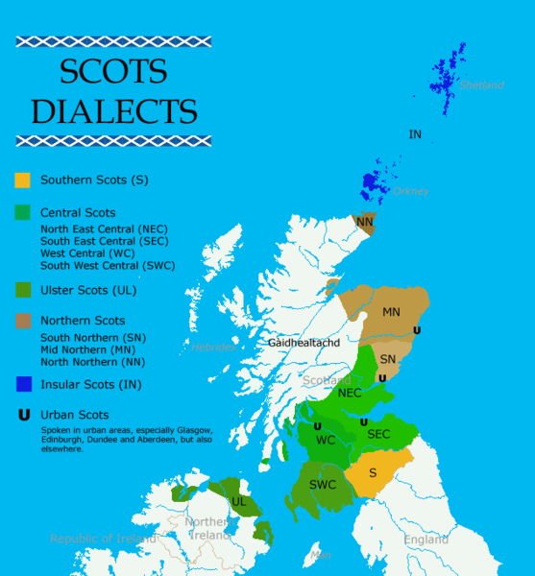

## Tutorial

* A
  + Some important varieties of Scots are:
    - Insular Scots (Orkney and Shetland)
    - Northern Scots
    - Central Scots
    - Ulster Scots
    - Southern Scots
    - Highland Scots
  + To explore more about different varieties of Scots, you can follow this link: https://www.scotslanguage.com/articles/node/id/69/type/referance
  + Some varieties may popularly be seen as "better" or "worse" than others; for example, Glaswegian Scots is stigmatised by many people. As linguists, however, we don't consider varieties as being "better" or "worse", just different in various ways.
* B
  + they books – Central, a bit Southern
  + quines – North East
  + peerie – Insular
  + I was like that – Central,
  + gonnae no – Central
  + eh – Central, Northern (Dundee)
  + chust (Highlands, Hebrides)
  + yous – Northern, Central, Southern
  + ken
  + pure Baltic – Glasgow (spreading)

I’ve read all they books. - This use of the demonstrative pronoun is characteristic of Glasgow and the Central Belt.

The quines was down here last week. - Quines 'girls' is used in the Northeast.

It was a wee peerie hoose wi’ nae windows. - Peerie 'small' is used in Shetland.

And I was like that ‘What you doin?’ - This is characteristic of Glasgow.

Gonnae no do that! - This form of the imperative is found in Glasgow and the Central Belt, though it may be spreading.

I’m off to the uni, eh. - The tag eh is found in Dundee.

You’ll catch her because she’s /tʃ/ust left. - This (pronouncing 'just' with a /tʃ/) is an example of devoicing, found in the Highlands and Hebrides.

Are yous goin out the night? - Yous as a second person plural pronoun is found in the Central Belt but is spreading.

Do you ken where Ben is? - Ken 'know' is widespread in Scotland but not usual in Glasgow.

It was pure baltic so it was. - The use of pure as an adverbial intensifier is used in Glasgow but likely spreading.

* B 2
  + my bed
  + needs washed
  + aye
  + …
  + …
  + doon
  + in the hospital
  + knifes
  + I’m not caring
  + Doesnae she come fae Aberdeen

I’m going to bed. (m) [to my bed]

This car needs washing. (m) [needs washed]

Don't say no, say yes! (l) [aye]

He sold his stereo for £100. (m) [selt]

Where are you off to today? (l) [the day]

She’s down in London this weekend. (p) [doon]

Were they good to you in hospital? (m) [the hospital]

The knives were really sharp. (p) [knifes]

I don’t care. (m) [I'm not caring]

Doesn’t she come fae Aberdeen? (m) [Does she not]

* C
  + Bands/singers:
    - Biffy Clyro
    - Lewis Capaldi
  + Shows:
    - Rebus
    - Outlander
    - Scots quad?

## Lecture 3: Scots in the Media

Homework – forms used in Scotland:

* throughout Scotland
  + “**I’m needing** a cup of coffee after that”
  + “I’m going to my bed”
* in the Central Belt only
  + “There it’s!” (discovery locative)
  + (“There it’s there” – a bit more widespread than just Central Belt)
* in the north east only
  + “**We was**”
  + I was, you was, he was, it was, the dogs was, but not they was
* more by older speakers
  + “**I’ll away** up the road”
* more by younger speakers – linguistic obsolescence
  + **yous**

Linguistic innovations – new forms appearing and spreading, rules:

* Negation
  + “She *willnae* (won’t) go there”
  + Can’t say “*Willnae* she go there?”
  + “*Will she no* go there?”

Varieties:

* Shetland
  + Lexical
    - peerier
  + Phonological
    - *th*- stopping
    - dis and dat
  + Grammatical
    - du (you)
    - I says “What’s du doing”?
* Reasons for existence of varieties:
  + Linguistic contact
    - Shetland – Scandinavian language Norn and (15th cent.) Scots
  + Geography
  + Duration of usage of variety
  + Sense of identity

History

* 1424: Inglis (Scots) replaces Latin as the official language of the Scottish parliament
* The Union of the Crowns 1603; Union of Parliaments 1707
* Rise of English as a ‘courtly’ or polite variety and ‘key to successful self-aggrandisement’ (McMahon 2000:142)
* By the turn of the 20th century, Broad Scots writing was largely confined to literature. Broad Scots speech was the domain of the rural peasanty and urban working classes

Print media

* The Scotsman – not much Scots
* The presence of Scots in the print media is mostly confined to totemic use of an individual Scots word in an otherwise English article
* The National (The Newspaper that supports and Independent Scotland) – Standard English

The radio (1923)

* A homogenous south eastern pronunciation as the typical ‘BBC accent’
* 1978: BBC Radio Scotland
  + From SSE to Broad Scots and everything in between
  + Educated Central Scottish accent preferred for news announcements and current affairs
  + Reporters, commentators and contributors to phone-in programmes and other vox pop segments have a wider range of regional and social varieties

TV and film

* SSE (David Tennant, Ewan McGregor)
* Central Belt Scots
  + ‘Given the stereotypical **gritty realism** associated with televised and filmed Scottish drama, most of the Scottish voices heard in films are more or less diluted versions of urban Central Scots’
    - Corbett, J. 2008. Scots, English and community languages in the Scottish Media. In Hutchison, D. and Blain, N. Scots in the Media
* Examples – portrayal as gritty realism or funny:
  + Good article – ‘Trainspotting’ made easy Americans (The Independent)
  + Sweet Sixteen (‘gritty realism’)
  + Still Game (comedy)

Literature

* Since the 18th cent., there have been regular ‘vernacular revivals’ or ‘renaissances’ in literary Scots: Robert Burns, Walter Scott, Robert Louis Stevenson, Hugh MacDiarmid
* These writers alternate between broad Scots and English in their published work
* Ex:
  + Shuggie Bain by Douglas Stuart
    - Douglas Stuart about voice and character:
      * Glaswegian is “inventive, expressive, frank, poetic, blunt as hell”
      * Americans should invest more in researching what words mean, the book is still accessible
    - Regional Scots in dialogue only
  + Hings: Short Stories ‘n’ That by Chris McQueer
    - “When I started writing it just felt natural to write how I talk”
  + HWFG by Chris McQueer
    - Written language similar to pronunciation in Scots

Social Media – Scottish Twitter

* ‘How Twitter is helping the Scots language thrive in the 21st century’ in The Conversation
  + ‘Scots on Twitter is a fascinating source of evidence about how aware people are of the subtle ways their speech differs from other people’s, and the creative ways they find to represent this’
* CAN’T
  + canny (Central Belt), canna (further North)

Writing as you speak

* ‘Non-standard orthographies have the potential to challenge linguistic hierarchies, for they can make non-standard voices visible/audible in a medium that habitually does not recognize them’
  + Jaffe, A. (2000), ‘Introduction: Non-standard orthography and non-standard speech’, *Journal of Sociolinguistics*, 4(4), 497-513

## Lecture 4: Revitalising Scots

Language shift

* The process whereby, over an extended period of time, a community of speakers shifts to a different language
* Languages that are perceived to be of higher status spread at the expense of other languages that are perceived to be lower-status
* Education
  + ‘Not a few teachers have allowed the use of provincial and ungrammatical forms of expression, false pronunciations, and vulgarisms to become so liar to them, that they have ceased to be conscious of it, and habitually counteract their instruction by their example’ (HMI, **1852**:168, quoted by Williamson)
  + ‘to speak local dialects was not only associated with the inability to speak Standard English, but also with a barrier to generic academic and social success’ (Williamson, **1983**: 58-9)

Reversing language shift, i.e., Revitalising

* Ex: Scottish Gaelic, Irish Gaelic, Welsh, Catalan
* Language planning
  + A **deliberate** effort to **influence** the function, structure, or acquisition of a language or language variety within a community
  + Often associated with government planning, but is also used by a variety of non-governmental organisations, such as grass-roots organisations and even individuals
    - Government planning
      * The European Charter
      * 2011 Census – question on Scots
      * Scots language policy (2015) (ability to read in Scots)
    - Grass-roots organisations
      * Oor Vyce
        + Campaign to give Scots legal status
      * Scots Language Forum (on Facebook)
    - Individuals
      * Len Pennie (Poet, made a video talking to Fingtam about Scots being a language)
* Corpus planning
  + Standardisation: one variety of a language takes precedence
    - Hard to do for Scots as there’s many varieties
  + Graphisation: development of orthographic conventions
    - Scottish Twitter doing a lot of work
  + Modernisation: expansion of lexicon for wider functional use
* Status planning
  + Increase the range of public functions in which the language is used
  + Raise status of language and thus gain acceptance by speakers
* Acquisition planning
  + Influence aspects of language and literacy through education
  + Developed more than previous 2 for Scots
  + Scots Language Policy 2015
    - 2 main aims:
      * ‘to promote a coherent approach to the planning, learning, teaching and assessment of Scots’
      * ‘to provide access to relevant resources which encourage the use and study of Scots’
  + Scots Language Award
  + Roald Dahl in Scots

Attitudes to Scots:

* Scots language activists/speakers get backlash for saying it’s a language:
  + Whit, Len Pennie
* 2020 survey saying 55% of people in Scotland speak Scots in their household (huge increase compared to 2011 Census’ 33%)
* Music in Scots more widespread
  + The Proclaimers
  + Twilight Sad

??? – lecture 5 recording